//creation of table and data load into hive

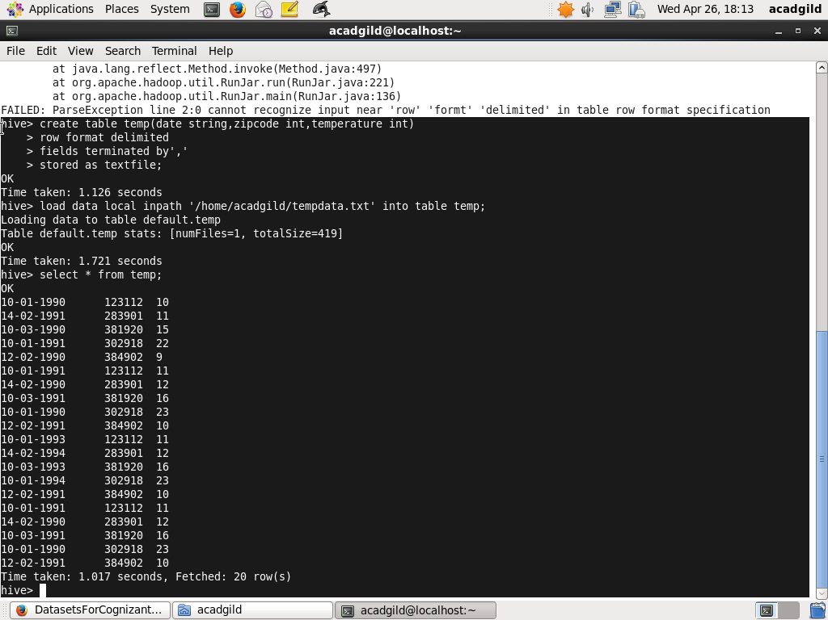

1. Fetch date and temperature from temperature_data where zip code is greater than 300000 and less than 399999

//query

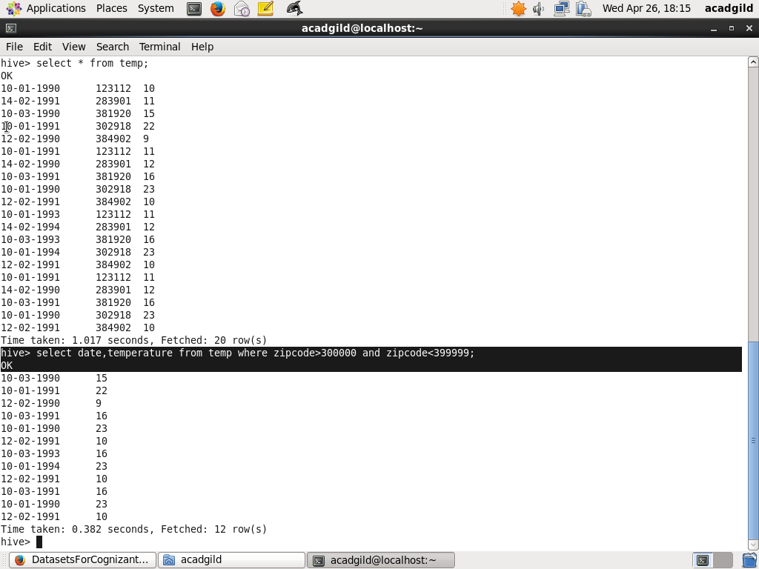

//result

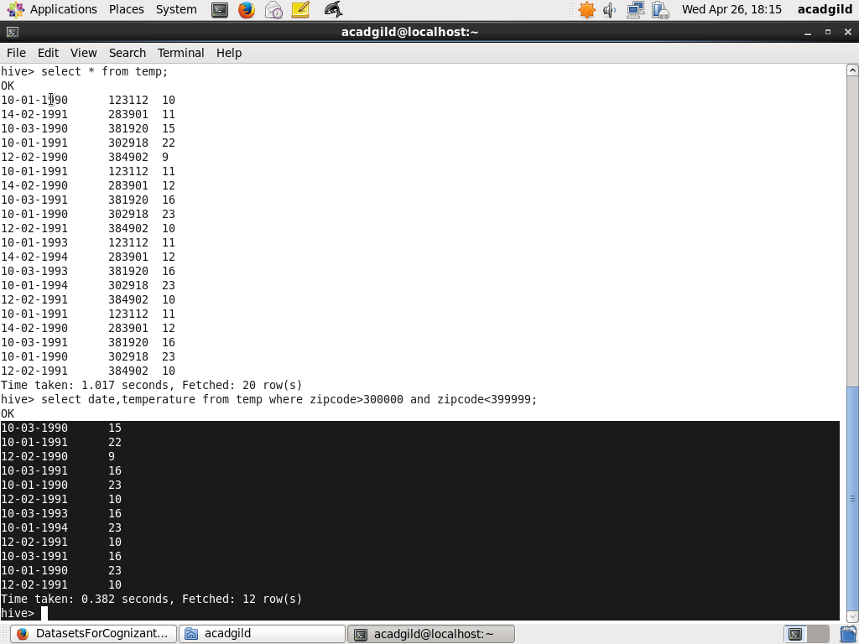

1. Calculate maximum temperature corresponding to every year from temperature_data table.

//query

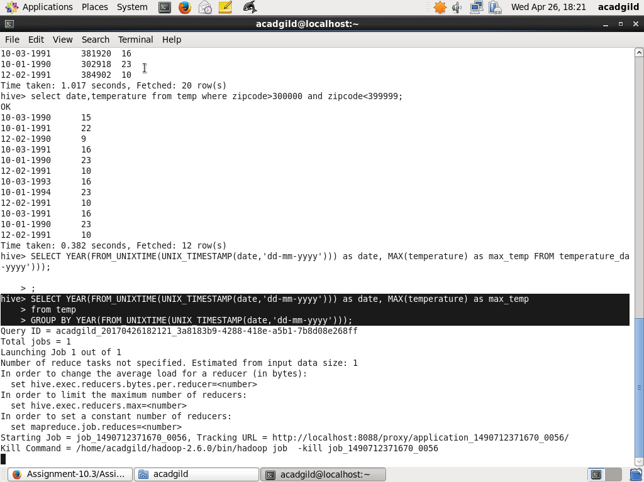

//result

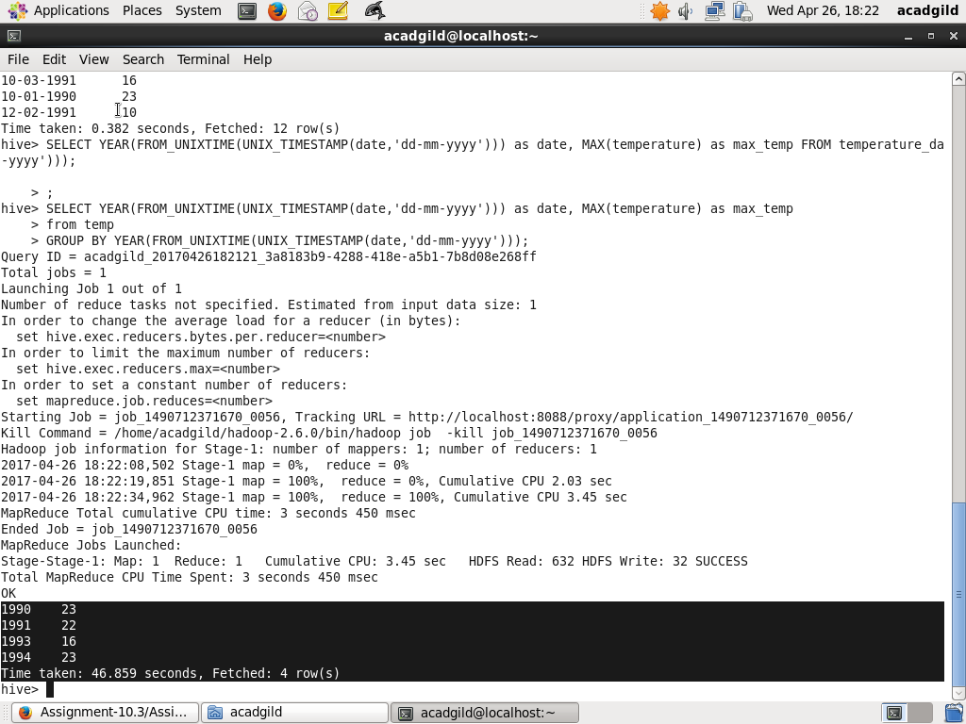

1. Calculate maximum temperature from temperature_data table corresponding to those years which have at least 2 entries in the table.

//query

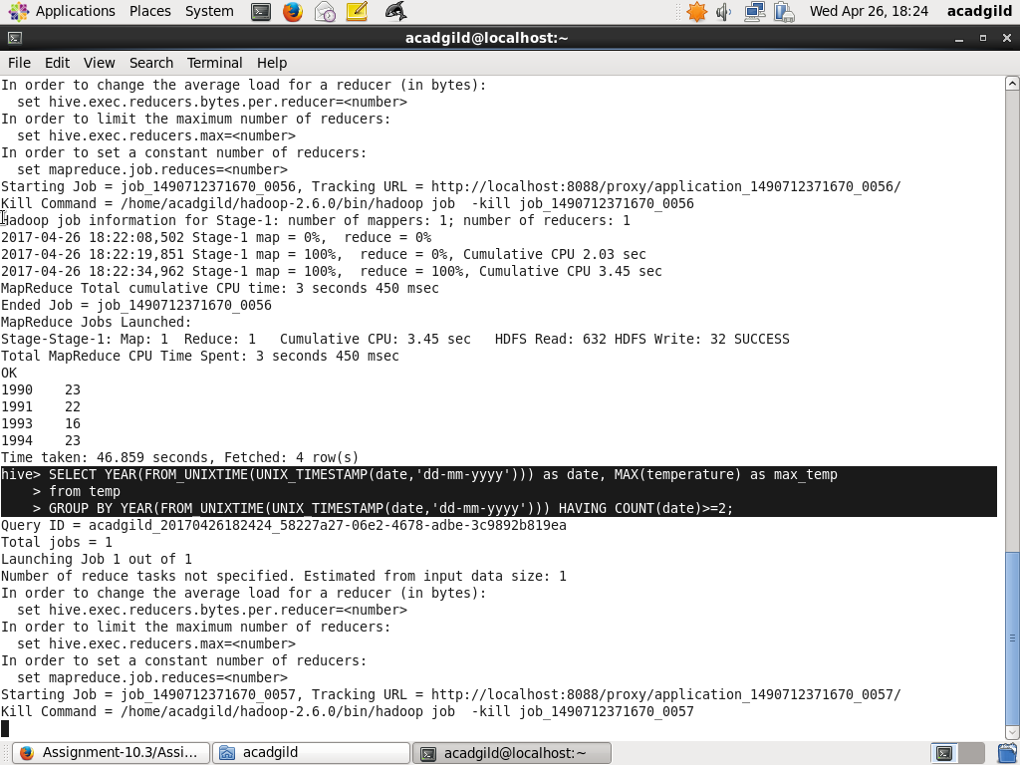

//result

